"Don't worry, Be Appy! Apps for Music Education"
CMEA Conference Jan 2014
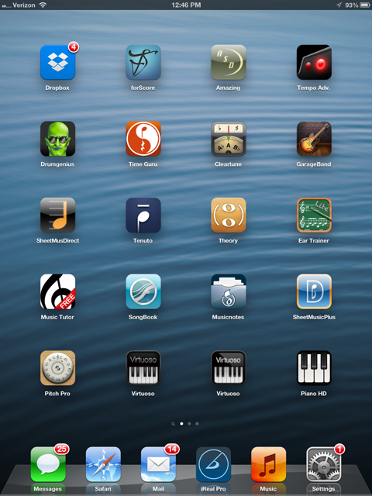
Michelle Hawkins
Associate Professor of Music
Skyline College
hawkinsm@smccd.edu

- iReal Pro - MusicBook & PlayAlong by Technimo LLC
$7.99
https://appsto.re/us/wzKXr.i

- Amazing Slow Downer by Roni Music
$14.99
https://appsto.re/us/-iVAs.i

- Time Guru Metronome by Decibel Consulting/Avi Bortnick
$1.99
https://appsto.re/us/kbIjz.i

- forScore by MGS Development
$6.99
https://appsto.re/us/iuJRv.i

- Drumgenius by Projazz Lab
Free
https://appsto.re/us/3y5vD.i

- Dropbox by Dropbox
Free
https://appsto.re/us/63ZHt.i

- Musicnotes Sheet Music Viewer by Musicnotes
Free
https://appsto.re/us/QZCcw.i

- Finale SongBook by MakeMusic, Inc.
Free
https://appsto.re/us/HoaKF.i

- Tempo Advance Metronome@ by Frozen Ape Pte. Ltd.
$2.99
https://appsto.re/us/tgD8v.i

- Cleartune - Chromatic Tuner by Bitcount ltd.
$3.99
https://appsto.re/us/3Bdgr.i
- Virtuoso Piano Free 3 by Peter Nagy
Free
- https://appsto.re/us/w5vxx.i

- Piano™ HD by YuXuanCentury
Free
https://appsto.re/us/aV6yF.i

- Tenuto by musictheory.net
$3.99

https://appsto.re/us/efjyB.i

- Theory Lessons by musictheory.net
$2.99

https://appsto.re/us/QWpzD.i

- Pitch Pipe+ by Frozen Ape Pte. Ltd.
$0.99

https://appsto.re/us/Gse6s.i

- iGigBook Sheet Music Manager by Black & White Software LLC
$14.99
https://appsto.re/us/PK2Nx.i

